Name: ___________________
Tinker v. Des Moines Independent Community School District | 1968
Directions: Read the following paragraphs and answer the questions in your own words below.
John and Mary Beth Tinker attended public school in Des Moines, Iowa in 1965. Their school did not allow students to wear armbands to protest the Vietnam War. However, the Tinkers decided to wear armbands to school anyway. The school officials asked the Tinkers to remove their armbands, but the Tinkers refused. John and Mary Beth Tinker were suspended from school until they agreed to remove the armbands.
- Who were John and Mary Beth Tinker? Why were they suspended from school?

The Tinkers sued the school district in the U.S. District Court. The Tinkers believed that the Des Moines school district violated their right to free speech under the First Amendment to the U.S. Constitution. Even though the students were not speaking with their voices, they believed that wearing armbands was like speaking. This is called symbolic speech.

- Why did the students sue the school district? What rights did they say the school violated?

The District Court sided with the school officials. The Court said that wearing the armbands could disrupt learning at the school. Learning without disruption was more important than the free speech of the students.
The Tinkers appealed their case to the next level of courts, U.S. Court of Appeals for the Eighth Circuit: But the Circuit Court agreed with the District Court. The Tinkers then appealed their case to the Supreme Court of the United States.
- What decision did the District Court make in the case? What was the reason for their decision?

The Court had to answer this basic question: Does the constitutional right of free speech protect the symbolic speech of public-school students?
In 1968, the Supreme Court of the United States agreed to hear the case of Tinker v. Des Moines. They issued their decision in 1969. The Supreme Court sided with the students and but said that as long as their actions do not disrupt the learning process, the students do have the right to express their views.

- What was the main question that the Supreme Court of the United States had to decide in the case of the Tinker students?

- How did the US Supreme Court decide the case? Do you think the judgement was fair? Why? If not, why not?

- The First Amendment says "Congress shall make no law . . . abridging the freedom of speech." Do you think that actions, like wearing an armband to protest, are the same as speech? Why or why not?

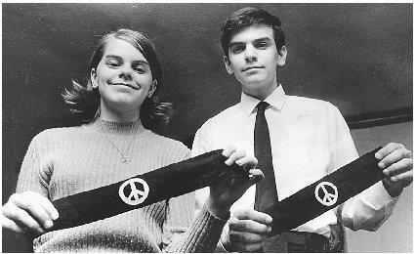

Mary-Beth and John Tinker at their high school in 1965

