Directions: Identify the propaganda technique used in each of the following images. The techniques are: Testimonials, Transfer, Glittering Generalities, Bandwagon, Plain Folks, Card Stacking and Name-Calling. There may be more than one technique used in each image.
Image 1
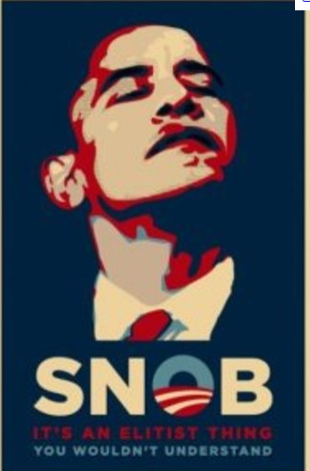

- What do you see in the image above?

- What propaganda techniques are used in this image?

- What is the message that you think the author of this message was trying to communicate to the viewer?

Image 2

- What do you see happening in the image above?

- What propaganda techniques are being used in this image?

- What do you think was the message that the advertiser was trying to communicate to the viewer?

Image 3

- What do you see happening in this picture?

- What propaganda techniques are being used in this image?

- What do you think the advertiser was trying to communicate to the viewer?

Image 4

- What do you see in the image above?

- What do you think is the propaganda technique(s) that are in this image?

- What do you think was the message that the author of this add was trying to communicate?

Image 5

- What do you see in the image above?

- What are the propaganda techniques you see in this image?

- What do you think is the message that the author was trying to communicate?

Image 6
- What do you see happening in this image?

- What techniques are being used in this image?

- What do you think is the message that the author was trying to communicate to the viewer?

Image 7

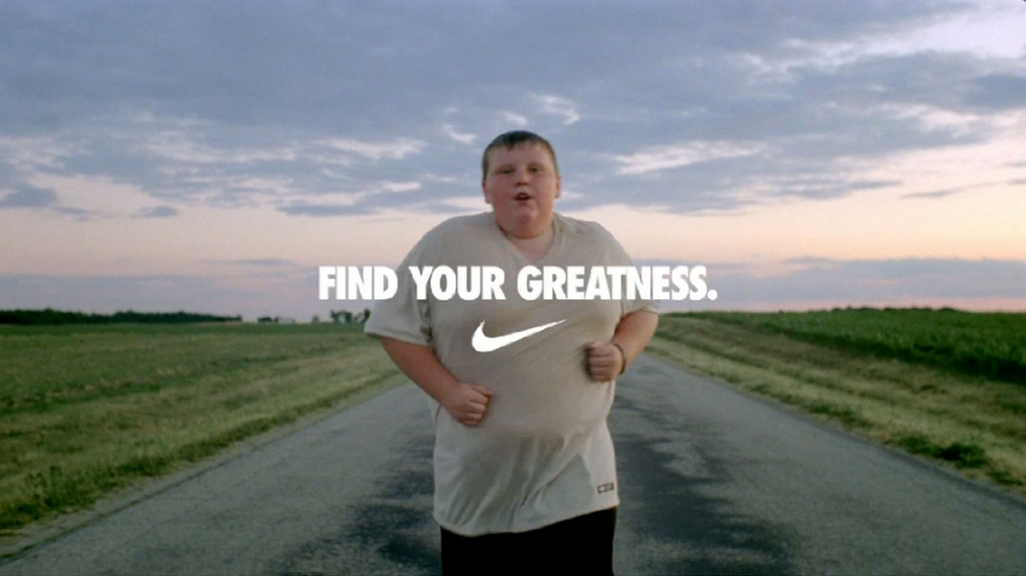

- What do you see happening in this image above?

- What propaganda techniques can you see in this image?

- What do you think was the message that NIKE was going for in this advertisement?

Image 8

- What do you see happening in the image above?

- What are the two propaganda techniques happening in this advertisement?

- What is the message that the author was trying to convey to the viewer?

