Recognizing Propaganda Techniques Name: ________________
Directions: Look at the following examples that you see below. Each example is of a propaganda technique that you just reviewed. Try and identify which propaganda technique goes with the images you see below and answer related questions under each image. The techniques are: Glittering Generalities, Transfer, Name-Calling, Bandwagon, Testimonial, Card Stacking and Plain Folks.
Image One:

- What is the image you see above?

- What propaganda technique is being shown in this image?

- What is this advertisement trying to get you to do?

Image 2
- What do you see in the image shown above?

- What do you think is the propaganda technique being used in this picture?

- What is the message that the Trump campaign was trying to send to voters by using this image?

Image 3
- This is a little different take on a classic propaganda technique. Rather than showing you a politician or famous person, there is just a brand name and a mother and child. What propaganda technique is being used in this picture?

- Why did you select the answer you did in question A, image 3? What is the message that the brand is trying to send to the viewer?

Image 4

- Look at the image above. What do you think is the propaganda technique being used in this image?

- What is the message that those people who put out this add are trying to send to the viewer.

- What information is left out in this advertisement? What is not being communicated to the viewer who sees this add?

Image 5
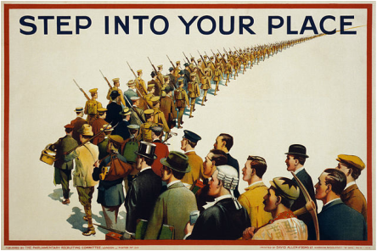
- What is the propaganda technique being used in this image?

- What is the message that is being sent to the viewer of this poster or add?

- This advertisement was put up during World War Two. Knowing that the United States as involved in the conflict, if you saw this poster, how would it make you feel?

- Do you feel that this add is effective? Why or why not?

