Political Cartoons
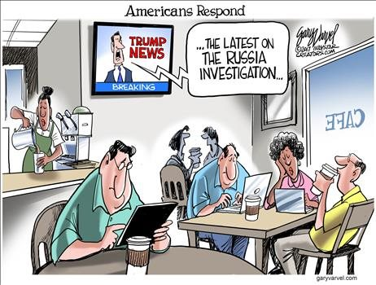
- What is the title of this cartoon? What do you think it means?

- What do you see happing in this cartoon?

- What do you think is the message that the author of the cartoon is trying to present to the viewer?

- What words are used in the cartoon that help you understand the message that the author wants you to take away from this cartoon?

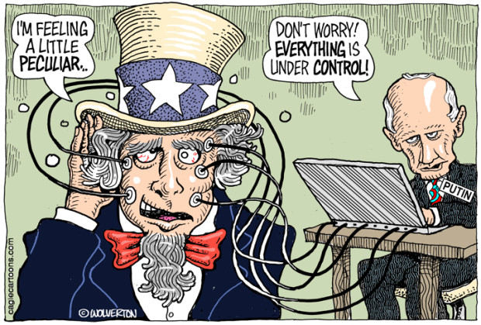
- What is happening in this cartoon?

- What words in this cartoon help you understand what is going on?

- What is the message that the author wants the viewers to take away from seeing this cartoon?

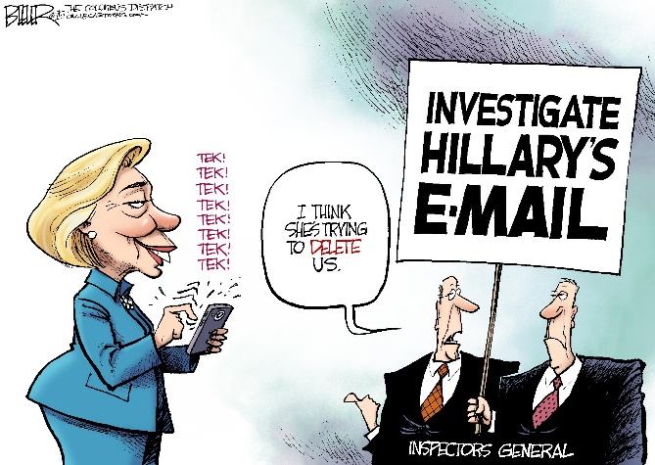
- What do you see happening in this cartoon?

- Are there any words or phrases that help you understand what is going on in this cartoon?

- What do you think is the message of this cartoon that the author wants you to know by viewing this cartoon?
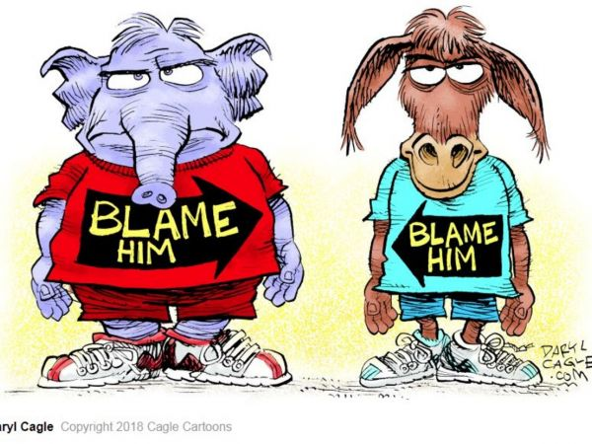
- What do you see in this cartoon?

- What do the two cartoon characters represent?

- What words or phrases help you understand what the cartoon is all about?

- What do you think was the message that the author was trying to present to the viewer through this cartoon?

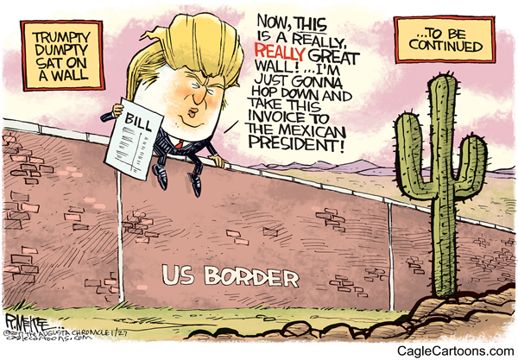
- What do you see happening in this cartoon?

- What words help you understand what is going on in this cartoon?

- What do you think is the message that the author wanted you to get from viewing the cartoon above?

