2.10 Media and Interest Group Logo Assignment

Directions: Create your very own logo of an interest group using Google slides or Google Docs. Make sure to do the following:
- Think about a problem in society that you would like to have solved? Then think of a tagline or phrase that helps people see what your group represents. Your group should communicate how you are trying to promote the common good. Example: MADD (Mothers against Drunk Driving.)
- Make your logo stand out. Your logo should be something that is both clearly visible, colorful but not too busy. People need to be able to clearly see what you stand for.
- Your logo should have:
- A name
- at least one symbol that represents the people you are trying to reach.
- Your logo should be colorful.
- Your logo should be neat.
- Your logo should have a general catch phase or statement that lets people know what the mission of your group is. Example: “Looking out for the workers of America, one worker at a time”, “Making sure all girls get an education”, Helping all boys, turn into men,” “Making sure no child gets left behind”.
- Bonus points for being original or making up your own logo!

Turn Over!!!

Here are some examples of interest group logos.

1, Boy Scoots of America, 2. Tim Horton’s (Canadian Coffee Chain, as a Children’s Camp for those kids who can’t afford to go to camp, 3. Mothers Against Drunk Driving, 4. Doctors without Borders, 5. Right to Play (A children’s organization designed to give kids in poor war torn and poor countries a chance to be able to play as kids)

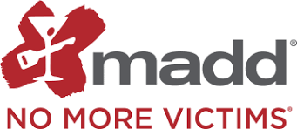

Evaluation of your Logo
Your logo will be worth 10 points and will be graded on the following breakdown:
- Do you have a clear logo for your group? Does it stand out and state what your group is all about. /3
- Is your logo colorful? Is it neat? /2
- On a separate slide, indicate what your group stands for, indicate what law you would like to have passed and why? /2
- How would your law benefit/ improve society? /3
Total: /10

