Name_________________________________________ Date_________________
STATE & LOCAL GOVERNMENT

State Government
Legislative Branch  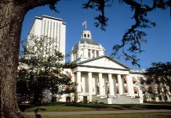 | Executive Branch  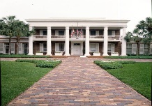 | Judicial Branch
Name of Houses: ______________________  ______________________  ___________________ | Name of Office:___________________ | Name of Office: ________________________
Roles and Functions: | Roles and functions: | Roles and Functions:

Local Government
________________________________________________________________________________________________________________________________________________________________________________________________________________________________________________________________________________________________________________________________________________________________________________________________________________________________________________________________________________________________________________________________________________________________________________________________________________________________________________________________________________________________________________________________________________________________________________________

