First Nine Weeks -Practice Review Name: ________________________
Bank Item Number |  | G.C.2.1.L1
Benchmark |  | SS.7.C.2.1
Cognitive Complexity |  | L
Item |  | Which is a requirement for a person to become a naturalized U.S. citizen?
A |  | Marrying a U.S. citizen and having a child with that person.
B |  | Being a legal resident of the U.S. for at least five years.
C |  | Gaining employment in the U.S. for at least five years.
D |  | Reaching age eighteen while living in the U.S. capital.
Civics 7

Directions: Circle the answer you think is correct for the questions below.

Bank Item Number |  | G.C.2.1.M1
Benchmark |  | SS.7.C.2.1
Cognitive Complexity |  | M
Item |  | The events below describe the use of a government document.  ---------------------------  Laura was born in France and lived in France until she immigrated to the U.S. at age 21. At age 25, Laura visited Morocco on vacation.  ---------------------------  Why did Laura use a U.S. passport to travel?
A |  | Laura was a resident alien of the U.S.
B |  | Laura was a resident national of the U.S.
C |  | Laura was a U.S. citizen by the law of soil.
D |  | Laura was a U.S. citizen by the law of blood.

Bank Item Number |  | G.C.2.1.M2
Benchmark |  | SS.7.C.2.1
Cognitive Complexity |  | M
Item |  | The passage below describes a court decision.  The Burlingame Treaty (1870) allowed the U.S. to deny citizenship to persons born in the U.S. whose parents were born outside the U.S. The U.S. Supreme Court granted writ of certiorari to a case challenging the constitutionality of the treaty.  How did the court apply the 14th Amendment to decide this case?
A |  | To deny a native person citizenship rights does not support constitutional principles.
B |  | A naturalized citizen possesses all the rights of a native citizen according to the Constitution.
C |  | Persons born outside the U.S. are not permitted to pursue citizenship because they are unemployed.
D |  | Persons born outside the U.S. are not permitted to pursue citizenship because they do not own property.

Bank Item Number |  | G.C.2.1.M3
Benchmark |  | SS.7.C.2.1
Cognitive Complexity |  | M
Item |  | Below is a table of the four most populated states in the United States.  State % of Naturalized Citizens from State’s Immigrant Population  California 46%  Florida 49%  New York 52%  Texas 32%  Source: Immigration Policy Center  How might these populations affect political campaigns?
A |  | Candidates for governor will campaign for immigration reform in Texas.
B |  | Candidates for president will campaign for immigration reform in Florida.
C |  | Candidates for governor will campaign for naturalization reform in California.
D |  | Candidates for president will campaign for naturalization reform in New York.

Bank Item Number |  | G.C.2.1.H1
Benchmark |  | SS.7.C.2.1
Cognitive Complexity |  | H
Item |  | The table below describes permanent resident status.  Year Number of Persons Obtaining Permanent Resident Status in the U.S.  2005 1,122,257  2007 1,052,415  2009 1,130,818  2011 1,062,040  Source: 2011Yearbook of Immigration Statistics (Table 1)  Based on the table, what could be predicted about the impact of permanent residents on government?
A |  | The number of persons seeking citizenship by law of soil would decline.
B |  | The number of persons seeking citizenship by law of blood would increase.
C |  | The number of persons seeking naturalization would be affected by elections for Congress.
D |  | The number of persons seeking naturalization would be affected by elections for governor.

Bank Item Number |  | G.C.2.2.M1
Benchmark |  | SS.7.C.2.2
Cognitive Complexity |  | M
Item |  | A citizen received the notification below in the mail.  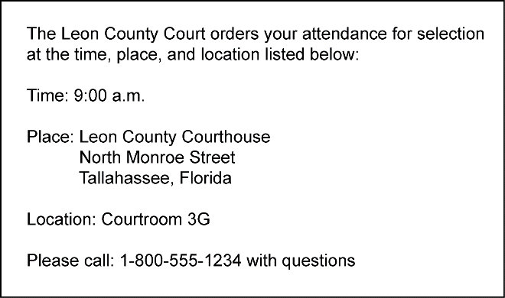  What civic responsibility does this notification represent?
A |  | getting a driver's license
B |  | appearing for jury duty
C |  | paying income tax
D |  | registering to vote

Bank Item Number |  | G.C.2.2.M2
Benchmark |  | SS.7.C.2.2
Cognitive Complexity |  | M
Item |  | Which type of service project would help promote the common good?
A |  | planning a neighborhood recycling program
B |  | participating in a neighborhood party
C |  | completing homework on time
D |  | visiting public libraries

Bank Item Number |  | G.C.2.2.M3
Benchmark |  | SS.7.C.2.2
Cognitive Complexity |  | M
Item |  | Which example is NOT a responsibility of citizenship?
A |  | volunteering in the community
B |  | attending civic meetings
C |  | voting in elections
D |  | paying taxes

Bank Item Number |  | G.C.2.8.M3
Benchmark |  | SS.7.C.2.8
Cognitive Complexity |  | M
Item |  | The conversation below is part of a political discussion.  ---------------------------  Lou: I am going to vote for the candidate who will support cutting government spending.  Bob: Yes, we spend too much on some programs.  ---------------------------  Which party’s candidates are these voters most likely to support?
A |  | Democratic
B |  | Green
C |  | Republican
D |  | Socialist

Bank Item Number |  | G.C.2.8.M2
Benchmark |  | SS.7.C.2.8
Cognitive Complexity |  | M
Item |  | Which spending increase would the Democratic Party likely support?
A |  | homeland security
B |  | space exploration
C |  | education
D |  | military

Bank Item Number | G.C.2.9.L1
Benchmark | SS.7.C.2.9
Cognitive Complexity | Low
Item | Which is a constitutional requirement to run for Congress?
A | U.S. permanent resident
B | at least 25 years old
C | at least 30 years old
D | U.S. citizen

Bank Item Number | G.C.2.9.M2
Benchmark | SS.7.C.2.9
Cognitive Complexity | Moderate
Item | The newspaper headline below describes a government process.  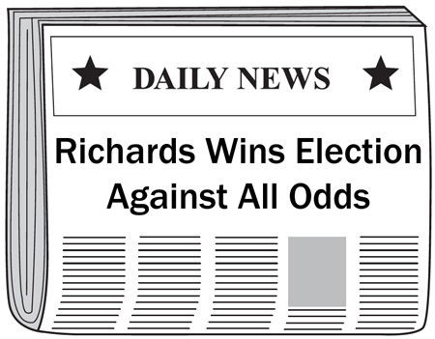  Why might this have been a difficult election for Richards to win?
A | Richards is a homeowner.
B | Richards is a party leader.
C | Richards has less political experience than his opponent.
D | Richards has less employment experience than his opponent.

Bank Item Number | G.C.2.9.M3
Benchmark | SS.7.C.2.9
Cognitive Complexity | Moderate
Item | A local newspaper endorsed Mayor Sanford in a state senate race over his opponent. Why might the newspaper endorse Mayor Sanford?
A | Mayor Sanford owns a local farm.
B | Mayor Sanford is an elected official.
C | Mayor Sanford is an experienced teacher.
D | Mayor Sanford owns a local radio station.

Bank Item Number | G.C.2.9.H1
Benchmark | SS.7.C.2.9
Cognitive Complexity | High
Item | The poster below is from a recent election.  Doug is pro-immigration!  Doug is pro-military!  Vote for Doug  Based on the poster, what conclusion can be drawn about the candidate?
A | Doug is running for judge.
B | Doug is running for mayor.
C | Doug is running for president.
D | Doug is running for city council.

Bank Item Number | G.C.2.10.L1
Benchmark | SS.7.C.2.10
Cognitive Complexity | Low
Item | Who do lobbyists represent in their attempts to influence government?
A | military officers
B | elected officials
C | interest groups
D | circuit judges

Bank Item Number | G.C.2.10.M2
Benchmark | SS.7.C.2.10
Cognitive Complexity | Moderate
Item | How might a political action committee influence government?
A | send a letter to a U.S. Senator’s supporters
B | contribute money to a U.S. Senate campaign
C | write a letter to a newspaper about a U.S. Senator
D | contribute money to a charity in a U.S. Senator’s state

Bank Item Number | G.C.2.10.H1
Benchmark | SS.7.C.2.10
Cognitive Complexity | High
Item | The table below describes ratings for news organizations.  Believability ratings of news organizations  Year % Reliable % Not Reliable  2012 56 44  2010 62 38  2008 64 36  2006 61 39  2004 63 37  2002 70 30  Source: Adapted from Pew Research Center poll conducted July 19-22, 2012.  According to the table, what impact has media had on government?
A | Government is less likely to regulate the press.
B | Government is more likely to regulate the press.
C | Government is less likely to respond to public concerns.
D | Government is more likely to respond to public concerns.

Bank Item Number | G.C.2.11.M1
Benchmark | SS.7.C.2.11
Cognitive Complexity | Moderate
Item | Which source would give the most accurate information about the views held by an incumbent running for Congress?
A | special interest group ratings of that Congress member
B | a television commercial sponsored by a political party
C | the voting record of the candidate while in Congress
D | flyers sent through the mail by the candidate

Bank Item Number | G.C.2.11.M2
Benchmark | SS.7.C.2.11
Cognitive Complexity | Moderate
Item | The passage below is from a U.S. Supreme Court decision.  The Federal Communications Commission (FCC) has for many years imposed …a “fairness doctrine,” requiring that public issues be presented by broadcasters and that each side of those issues be given fair coverage.  Source: Red Lion Broadcasting Co., Inc. v. Federal Communications Commission (1969)  Based on the passage, what is a goal of the FCC regulation?
A | to limit bias in political communication
B | to promote bias in political communication
C | to limit symbolism in political communication
D | to promote symbolism in political communication

Bank Item Number | G.C.2.11.H1
Benchmark | SS.7.C.2.11
Cognitive Complexity | High
Item | The poster below was placed in public buildings, businesses and schools by a civil rights group.  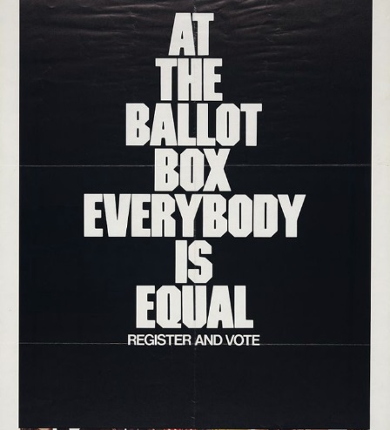  What is a long term policy goal of the interest group?
A | electing candidates
B | regulating elections
C | improving citizens’ lives
D | influencing political appointments

Bank Item Number | G.C.2.13.L1
Benchmark | SS.7.C.2.13
Cognitive Complexity | Low
Item | Which option represents a way that multiple perspectives are reflected in political participation?
A | public meetings
B | press conference
C | legislative sessions
D | State of the Union address

Bank Item Number | G.C.2.13.M1
Benchmark | SS.7.C.2.13
Cognitive Complexity | Moderate
Item | The headline below describes an event in U.S. history.  Source: Library of Congress  Which public policy view is reflected in the headline?
A | racial discrimination
B | racial prejudice
C | racial tolerance
D | racial equality

Bank Item Number | G.C.2.13.M2
Benchmark | SS.7.C.2.13
Cognitive Complexity | Moderate
Item | Which option reflects a long term policy goal?
A | collecting canned food to give to the poor
B | collecting signatures to run for public office
C | collecting soap and shampoo to send overseas
D | collecting signatures to put an amendment on the ballot

