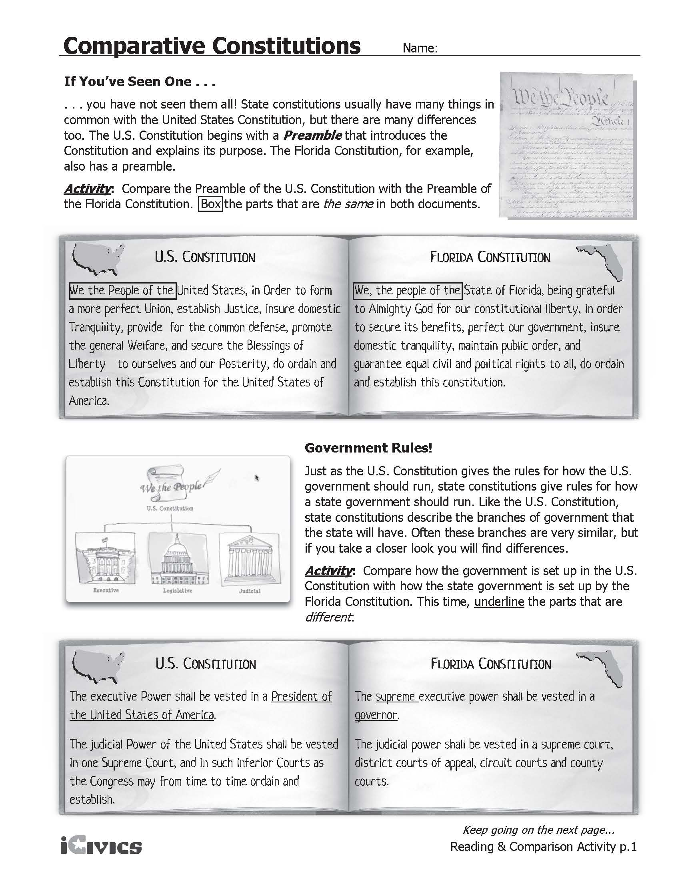
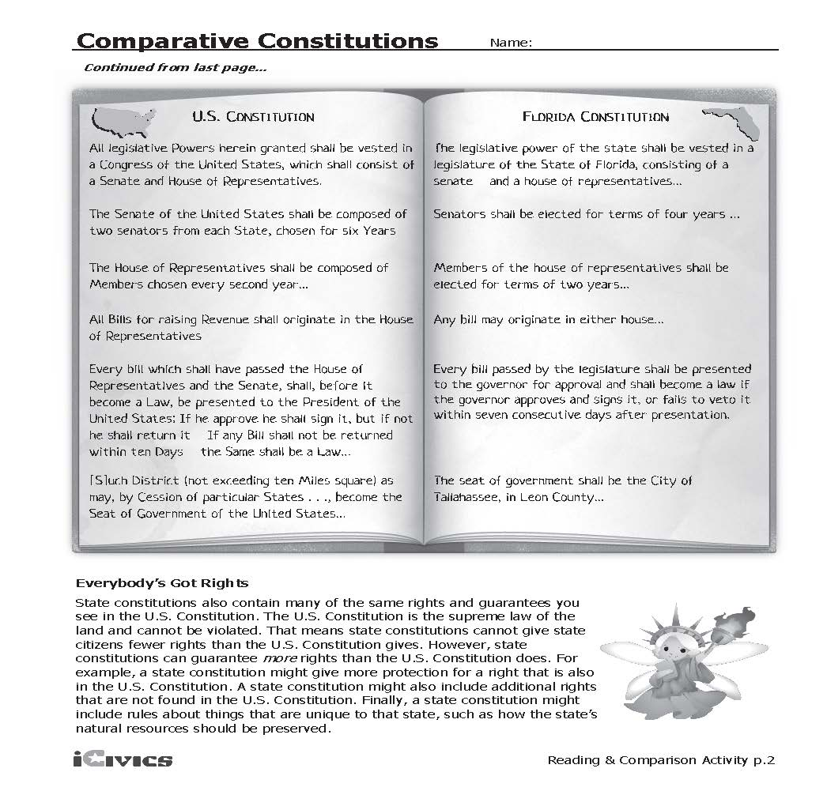
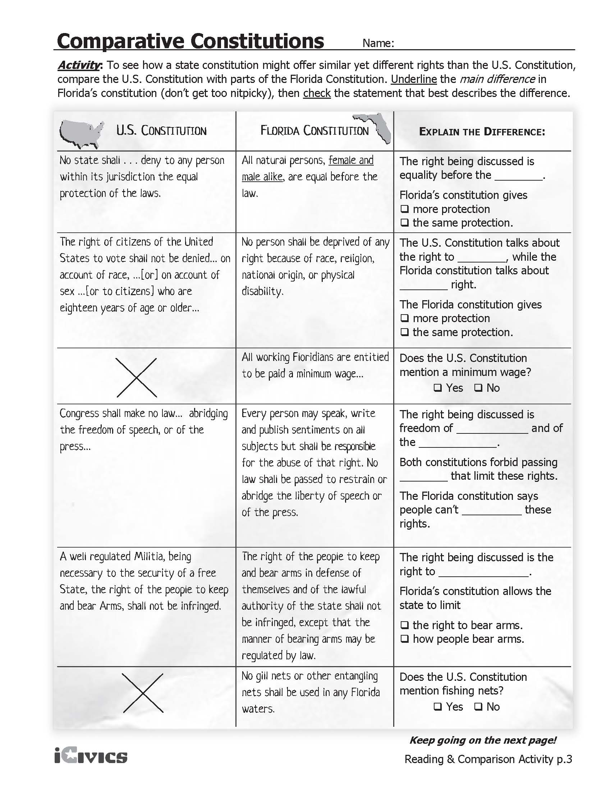
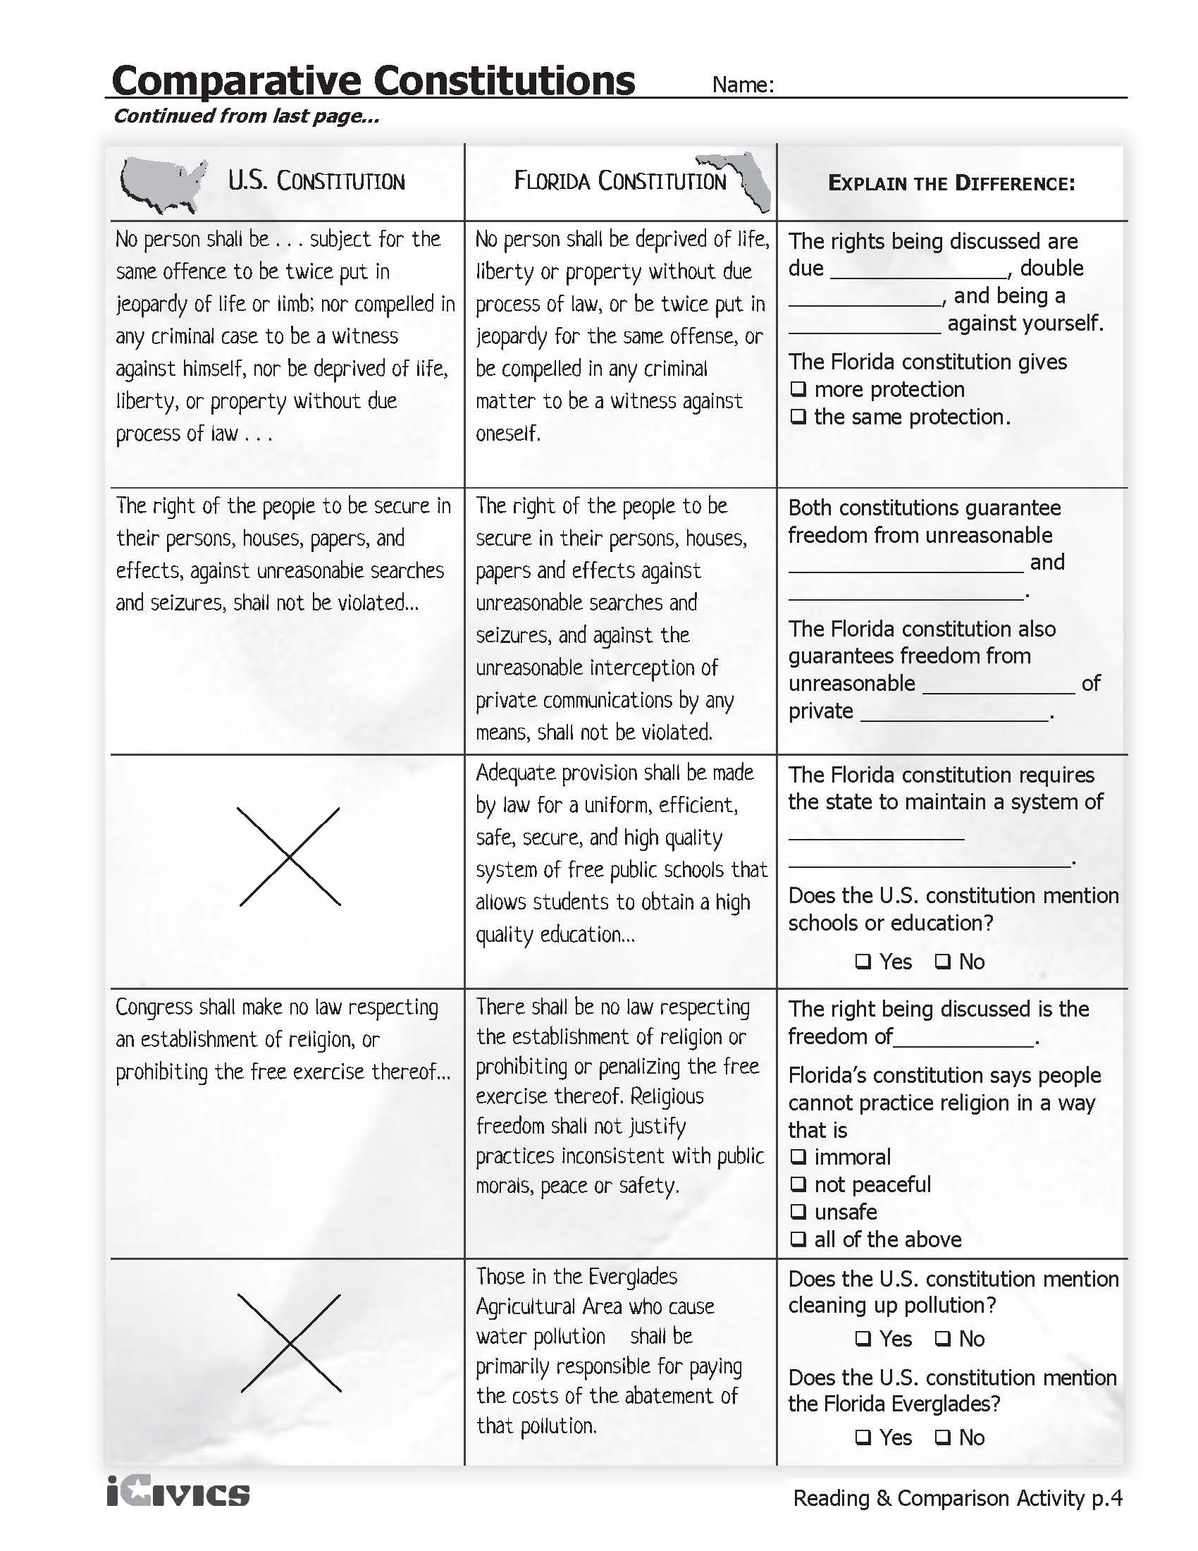
Article V - Amendment
The Congress, whenever two thirds of both Houses shall deem it necessary, shall propose Amendments to this Constitution, or, on the Application of the Legislatures of two thirds of the several States, shall call a Convention for proposing Amendments, which, in either Case, shall be valid to all Intents and Purposes, as part of this Constitution, when ratified by the Legislatures of three fourths of the several States, or by Conventions in three fourths thereof, as the one or the other Mode of Ratification may be proposed by the Congress; Provided that no Amendment which may be made prior to the Year One thousand eight hundred and eight shall in any Manner affect the first and fourth Clauses in the Ninth Section of the first Article; and that no State, without its Consent, shall be deprived of its equal Suffrage in the Senate.

Amending the U.S. Constitution
This Article explains the ways our Constitution may be changed, or amended.
One method of amending the Constitution is for 2/3 of each house (287 of the 435-member House of Representatives, and 66 of the 100 Senators) to pass a proposed amendment and send it to the states’ legislatures. It takes 3/4 (38) states’ approval of the amendment in order for it to be added to the Constitution
We the People do not directly vote on new amendments, and the President does not vote on or veto any amendment.
Another method for amending the Constitution is a Constitutional Convention to be called for by 2/3 (33) of the state legislatures. At such a convention, one or more amendments can be proposed and then sent to the state legislatures (or state conventions) for approval – again, 3/4 of the state legislatures must approve. (This method has not been used successfully).
Source: http://const4kids.forums.commonground13.us/ as amended, Accessed September 2011.

Amending the Florida Constitution
What does it take to amend the Florida Constitution?
In the spaces below, write a brief summary of each method, and draw an illustration that symbolizes each method.
Method | Description | Illustration

