CASE STUDY 2: FREEDOM OF ASSEMBLY NAME: ________________
This case study focuses on the following civics vocabulary terms:

- civil disobedience - the refusal to obey certain laws as a form of political protest

- freedom of assembly – the right to hold meetings and form groups without interference by the government; guaranteed in the 1st Amendment

Directions: You should work in a group of 2 for this assignment. Answer the following questions on the concept of the “freedom of assembly”.

- What do you think when you hear the term “freedom of assembly"?

- Is freedom of assembly important to you? Why?

- Are you a part of a group that is important to you either within the school community or outside of school that is important to you? Why is it important?

- What would you do if someone attempted to take that group away from you or break it up in some way?

- What does your reaction say about the value of this group?

- When should freedom of assembly be seen as illegal? Why?

Directions: Read the following historical account together in your group.
Bloody Sunday

In 1965, at the height of the modern Civil Rights Movement, activists organized a march for voting rights from Selma, Alabama, to Montgomery, Alabama, the state capital. On March 7, some 600 people assembled at a downtown church, knelt briefly in prayer, and began walking silently, two-by-two through the city streets.

With Hosea Williams of the Southern Christian Leadership Conference (SCLC) leading the demonstration, and John Lewis, Chairman of the Student Nonviolent Coordinating Committee (SNCC), at his side, the marchers were stopped as they were leaving Selma, at the end of the Edmund Pettus Bridge, by some 150 Alabama state troopers, sheriff ’s deputies, and white men, who ordered the demonstrators to break up their assembly and leave.

One minute and five seconds after a two-minute warning was announced, the troops advanced, wielding clubs, bullwhips, and tear gas. John Lewis, who suffered a skull fracture, was one of fifty-eight people treated for injuries at the local hospital. The day is remembered in history as “Bloody Sunday.” Less than one week later, Lewis recounted the attack on the marchers during a federal hearing at which the demonstrators sought protection for a full-scale march to Montgomery.
John Lewis (in the foreground) being beaten by state troopers, March 7, 1965
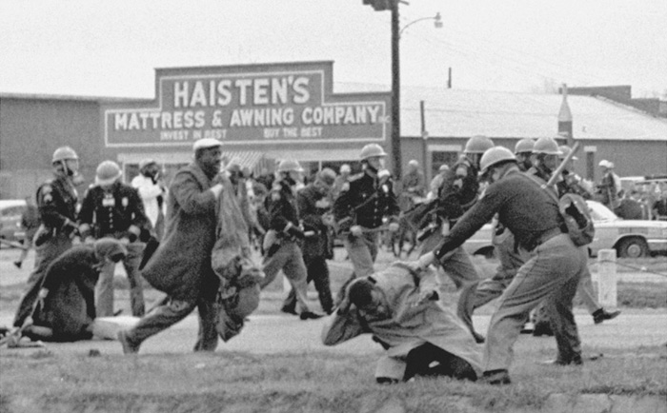
- With your partner, discuss what do you think happened in this case?

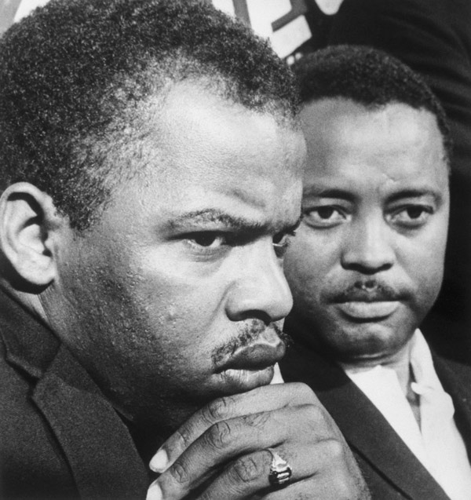
Six months after “Bloody Sunday,” President Lyndon B. Johnson signed into law the Voting Rights Act. One of the pens used by the President hangs framed today in the living room of Representative John Lewis, Fifth U.S. Congressional District of Georgia. He has been elected to that office nine times.

John Lewis (left) and Hosea Williams, July 26, 1965

Directions: As a group, look at the photographs on above and answer the following questions.

Question | Photograph of John Lewis being beaten by state troopers | Photograph of John Lewis and Hosea Williams
What people doing in the photos?
What objects are in the photos?
What activities are going on in the photos?
Based on what you observe, what might you conclude from these photos?
What questions do they raise in your mind?

Discuss the following questions as a class.

- Why do you think the State of Alabama had a law against these types of marches which lead to the incident described in the story, “Bloody Sunday”?

- What would be the reason why the state troopers would want to break up this kind of a protest?

- In general, why are protesters sometimes willing to go to jail when they assemble in a protest that they think is important to them, such as this one?

- The First Amendment says the government may not violate our right to freedom of assembly, yet there are limits to this right. In your opinion, is it ever good for our society to limit freedom of assembly? Why?

- Do you think civil disobedience can have a positive effect on society? Why or why not? Under what circumstances might it be okay?

- At the end of the hearing, on March 17, Judge Frank Johnson, Jr., ruled that the demonstrators had a constitutional right to march. On March 21, under the protection of a Federalized National Guard, 3,200 demonstrators set out from Selma in a mass demonstration that became a turning point in the civil rights movement. Why do you think the judge made this ruling?

7. As a group write a paragraph of at least 5 sentences responding to the following questions Why is freedom of assembly so important in a democratic society? Why are there some limits on freedom of assembly? Write your answer below.

