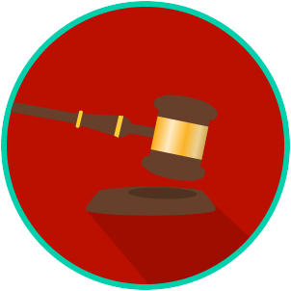
The Legal System: SS.7.C.3.12
Landmark Supreme Court Civil Rights Cases
VIDEO VIEWING GUIDE
Name: ________________________________

Date: _________________________________
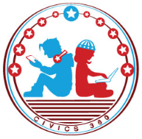
Directions: Watch the video for benchmark 3.12 on Civics 360 to answer the following questions. Make sure to take the quiz at the end and document it on this assignment. Make sure to use the following site to access the video and quiz: www.civics360.org

Question | List Specific Evidence from the Video | Complete Sentence
1. What make a court case a landmark case?

2. What are ‘civil rights’?
3. What power did the Supreme Court claim after the Marbury v. Madison (1803) case?
4. What does it mean when something is unconstitutional?
5. Explain the principle of judicial review.

6. Why did Plessy argue that the equal protection clause of the 14th Amendment had been violated?
7. How did the Supreme Court decision in Plessy v. Ferguson impact society?
8. What did the Supreme Court conclude in Brown v. Board of Education (1954)?
9. How did the constitutional principle in Brown v. Board of Education impact society?
10. How might schools today be different if the Supreme Court ruled against Brown?
11. Why was Gerald Gault denied due process when he was arrested?
12. What is the impact of in re Gault (1967) on society?

The Legal System: SS.7.C.3.12
Landmark Supreme Court Civil Liberties Cases
VIDEO VIEWING GUIDE #1
Name: ________________________________

Date: _________________________________

Landmark Supreme Court Civil Liberties Cases Video #1
Question | List Specific Evidence from the Video | Complete Sentence
1. What do we mean when say it is a ‘landmark case’?

2. What are ‘civil liberties’?
3. What power did the Supreme Court claim after the Marbury v. Madison (1803) case?
4. Why did Gideon believe his rights had been violated?
5. What do you think the Supreme Court meant when it said that a lawyer was NOT a luxury?
6. How did Gideon v. Wainwright (1963) impact society?
7. Why did Miranda believe his rights had been violated?
8. How did Miranda v. Arizona (1966) impact society?
9. How did both Gideon v. Wainwright (1963) and Miranda v. Arizona (1966) impact civil liberties in the United States?
10. What was the constitutional question in Tinker v. Des Moines (1969)?
11. How did the constitutional principle argued in Tinker v. Des Moines (1969) impact society?
12. What was the constitutional question in Hazelwood School District v. Kuhlmeier (1987)?
13. How did the constitutional principle argued in Hazelwood School District v. Kuhlmeier (1987) impact society?

In Tinker v Des Moines (1969), the US Supreme Court said the following: “In wearing armbands, the petitioners were quiet and passive. They were not disruptive, and did not impinge upon the rights of others. In these circumstances, their conduct was within the protection of the Free Speech Clause of the First Amendment and the Due Process Clause of the Fourteenth.”

How might the language here have influenced the decision the Supreme Court reached in the later student First Amendment case of Hazelwood School District v. Kuhlmeier (1987)?

The Legal System: SS.7.C.3.12
Landmark Supreme Court Civil Liberties Cases
VIDEO VIEWING GUIDE #2
Name: ________________________________

Date: _________________________________

Landmark Supreme Court Civil Liberties Cases Video #2
Question | List Specific Evidence from the Video | Complete Sentence
1. What make a court case a landmark case?

2. What are ‘civil rights’?
3. What power did the Supreme Court claim after the Marbury v. Madison (1803) case?
4. What happened at the Watergate Hotel in the 1970’s that helped lead to the case ‘United States v. Nixon’?
5. What is executive privilege?

6. Why did Nixon believe he did not have to turn over recordings or tapes to help in the Watergate investigation?
7. What argument did the government make in United States v. Nixon (1974)?
8. What impact did the case of United States v. Nixon (1974) have on society?
9. What role did the state of Florida play in the case Bush v. Gore (2000)?
10. According to the Bush campaign, why would not stopping the recount in Florida have been seen as a violation of the 14th Amendment’s Equal Protection Clause?
11. What is a precedent?

12. Why did the Supreme Court believe the Florida recount violated the 14th Amendment?
13. How might the decision in Bush v. Gore (2000) be an example of the Supremacy Clause in action?
14. What constitutional right did Heller argue was being violated by Washington, D.C. in the District of Columbia v. Heller (2008) case?
15. How did the decision of the Supreme Court in District of Columbia v. Heller (2008) impact society?
16. Based on what you learned about the U.S. Supreme Court in United States v. Nixon, how would you respond to a president who declares that ‘If a president does it, that means it is NOT illegal’?

The Legal System: SS.7.C.3.12
Landmark Supreme Court Cases
PRACTICE QUIZ
Name: ______________________

Date: _______________________
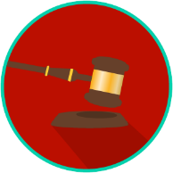
Landmark Supreme Court Cases Practice Quiz Reflection

FIRST Attempt Score | I answered ______ questions right.
One thing I learned:

SECOND Attempt Score | I answered ______ questions right.
One thing I learned:

