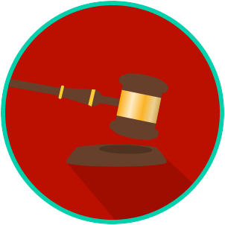
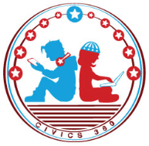
The Legal System: SS.7.C.3.11/C.2.6
State & Federal Courts
VIDEO VIEWING GUIDE #1
Name: ________________________________

Date: _________________________________

State Courts Video #1
Question | List Specific Evidence from the Video | Complete Sentence
1. What is jurisdiction?

2. What are the four levels of the court system in Florida?
3. What is an appellate court?
4. If you want to sue someone for $15,000, to which level of the Florida court system would you bring your case?
5. Explain why a plaintiff or a defendant cannot win a trial within a District Court of Appeal?

The Legal System: SS.7.C.3.11/C.2.6
State & Federal Courts
VIDEO VIEWING GUIDE #2
Name: ________________________________

Date: _________________________________

Federal Courts Video #2
Question | List Specific Evidence from the Video | Complete Sentence
1. Which section of the U.S. Constitution outlines the federal court system?

2. What are the three levels of the federal court system?
3. Your friend tells you that she just found out her case will be heard by the U.S. Supreme Court. What kind of question would your friend’s case involve?
4. What are three of the eight kinds of cases federal courts hear?
5. Why can’t a jury ever find anyone guilty of a crime within a U.S. Court of Appeals?

The Legal System: SS.7.C.3.11/C.2.6
State & Federal Courts
VIDEO VIEWING GUIDE #3
Name: ________________________________

Date: _________________________________

Powers of State and Federal Courts Video #3
Question | List Specific Evidence from the Video | Complete Sentence
1. Where are the powers and jurisdictions of the Florida court system described?

2. What is the name of the highest court in Florida?
3. Where does the federal court system get its powers and jurisdictions?
4. What is the name of the highest court in the United States?

Name: _____________________

Date: ______________________
The Legal System: SS.7.C.3.11/C.2.6
State & Federal Courts
PRACTICE QUIZ
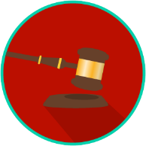
State and Federal Courts Practice Quiz Reflection

FIRST Attempt Score | I answered ______ questions right.
One thing I learned:

SECOND Attempt Score | I answered ______ questions right.
One thing I learned:

